**Linux**

To create user and password:

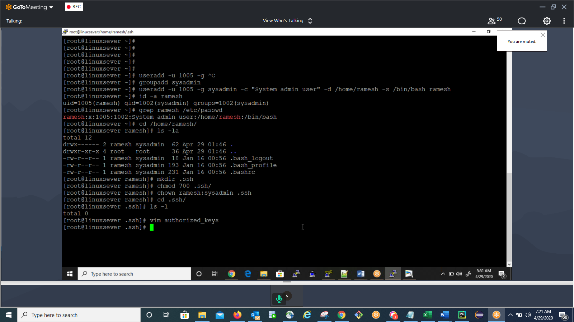

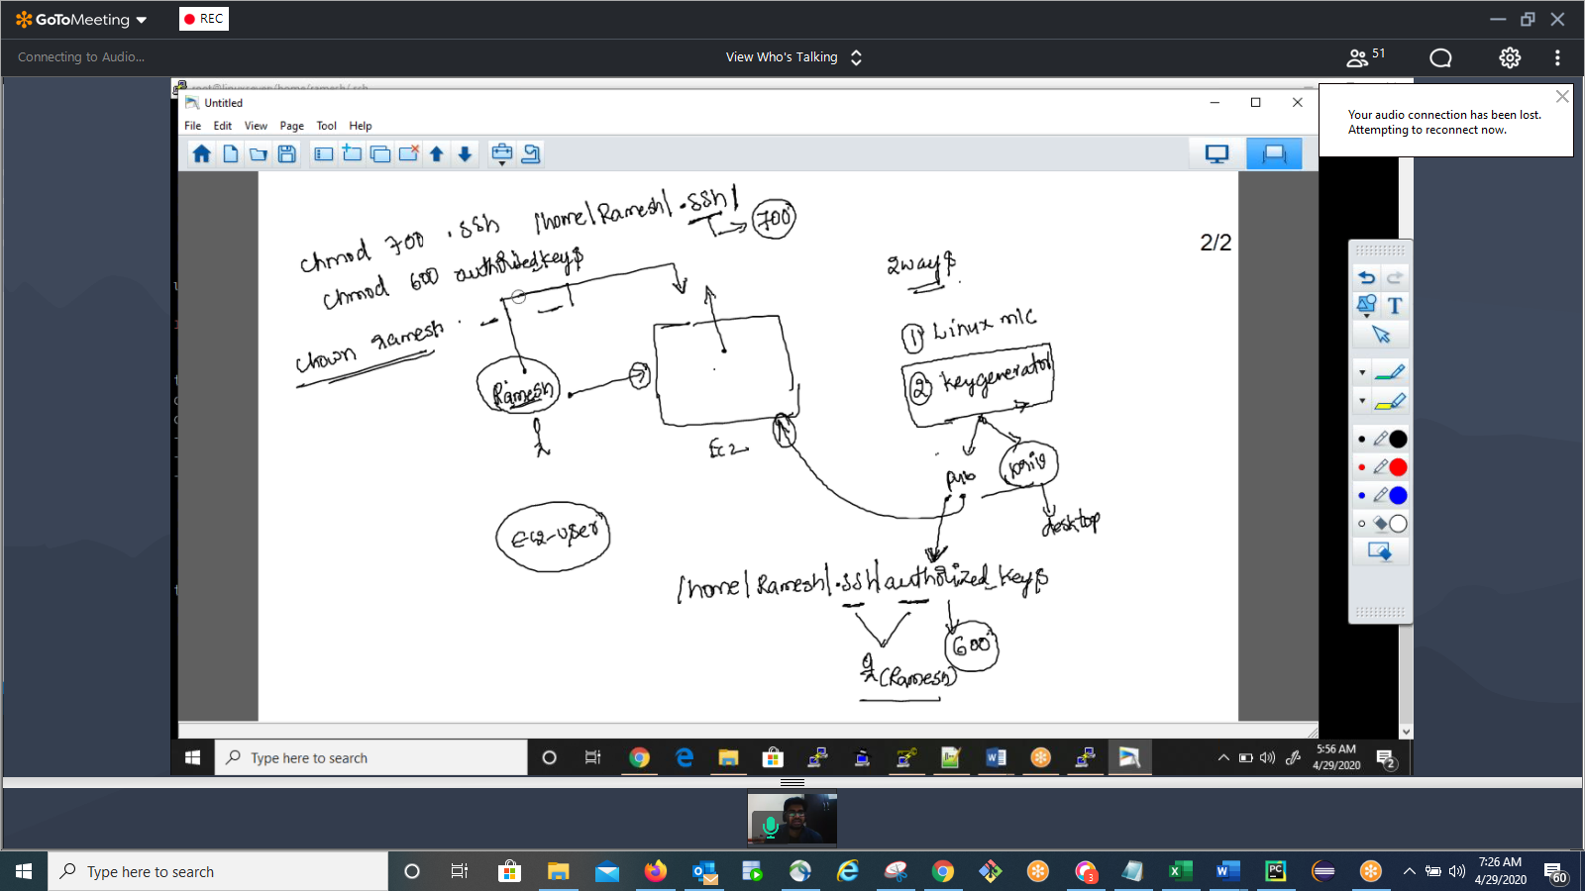

Password expiry issue:

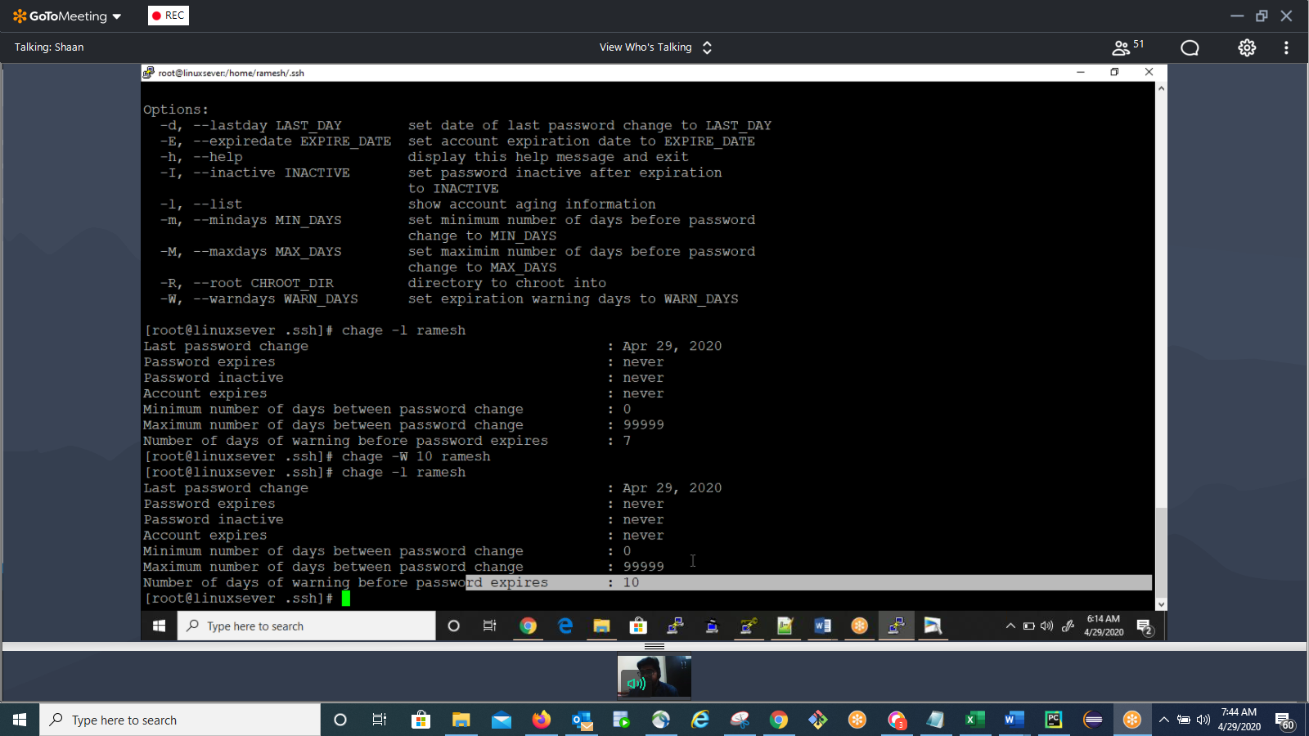

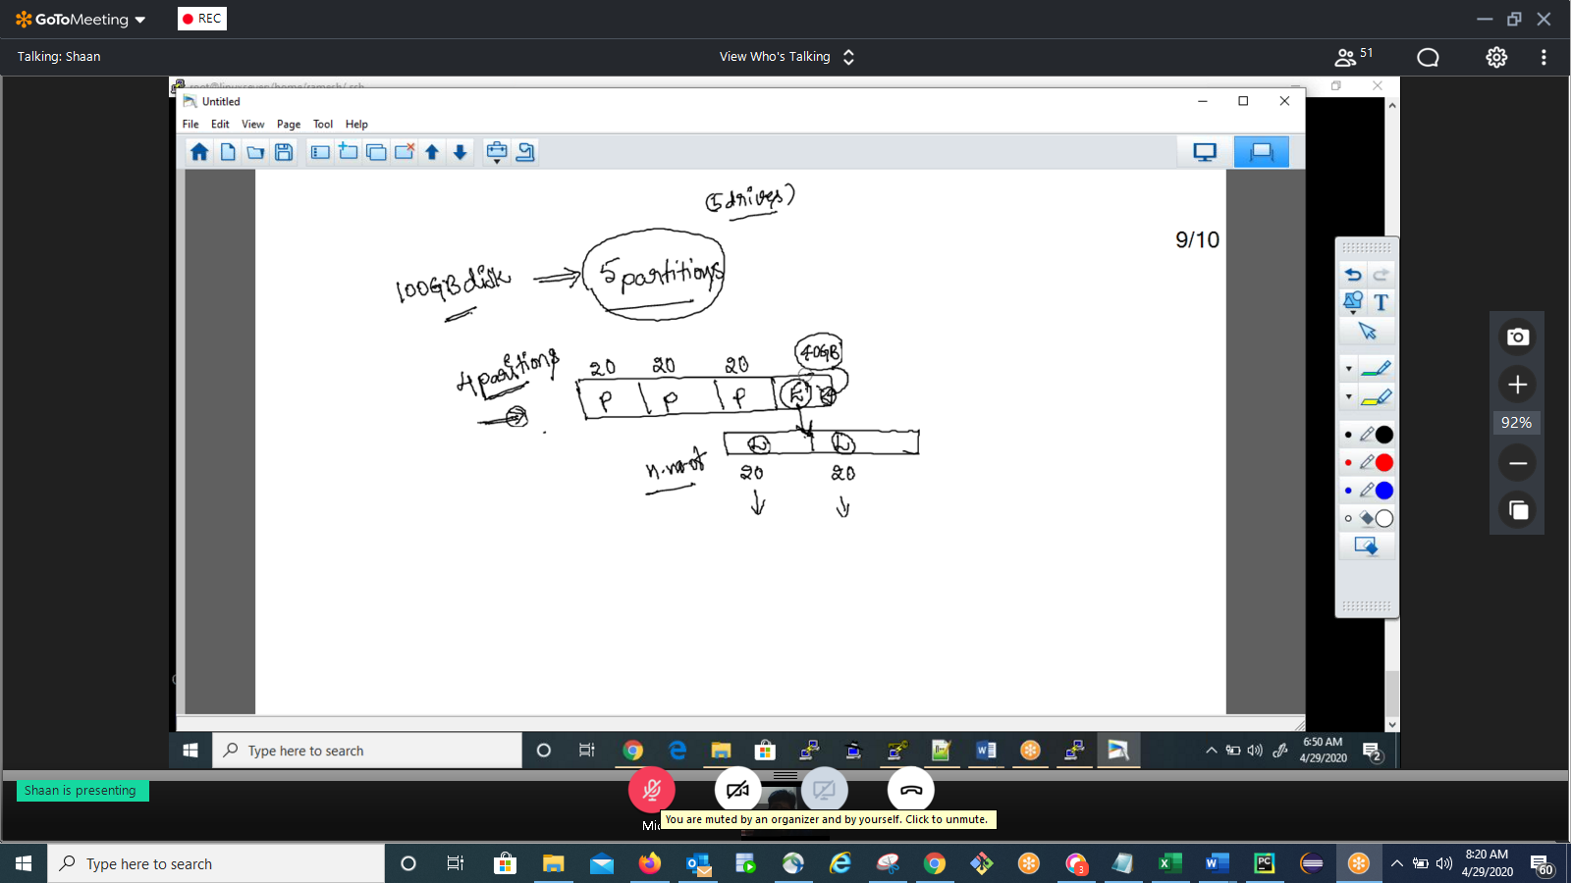

If condition:

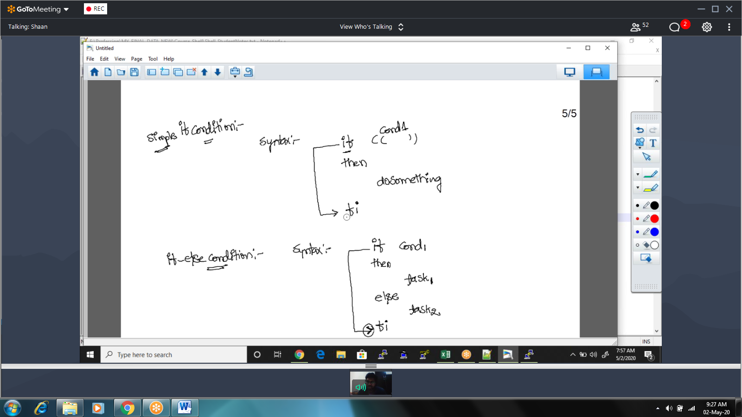

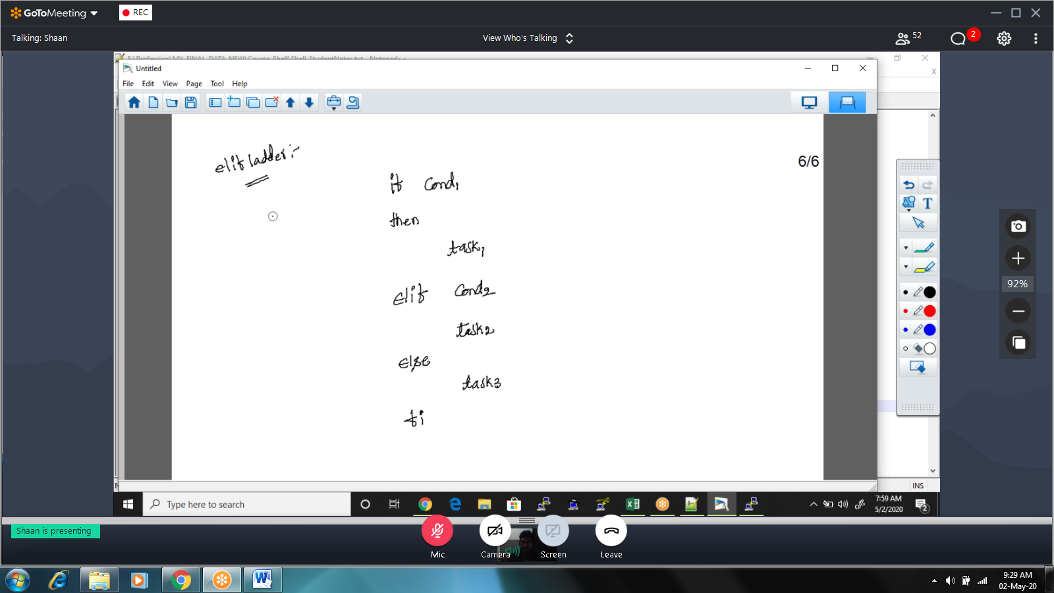

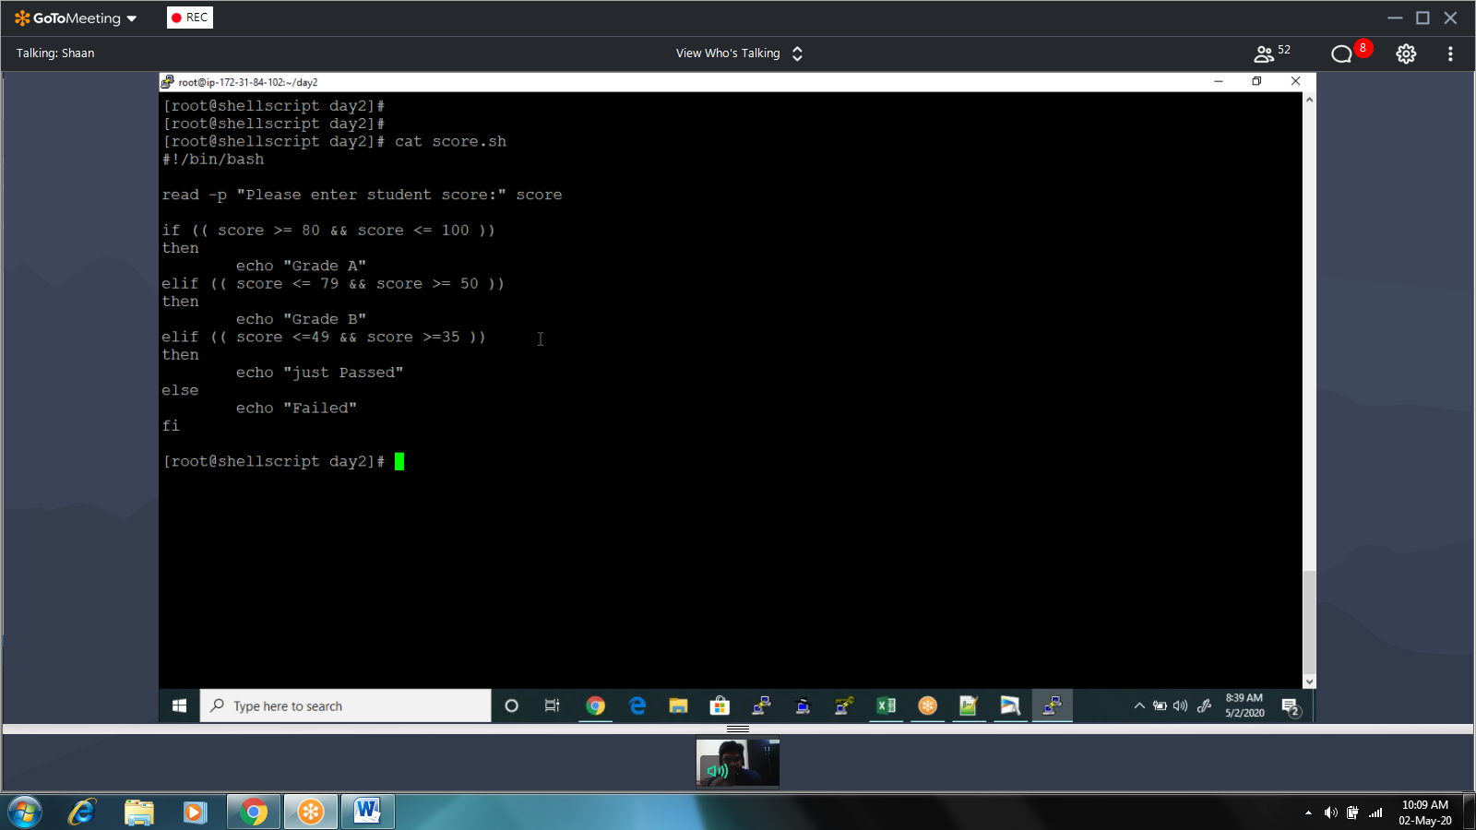

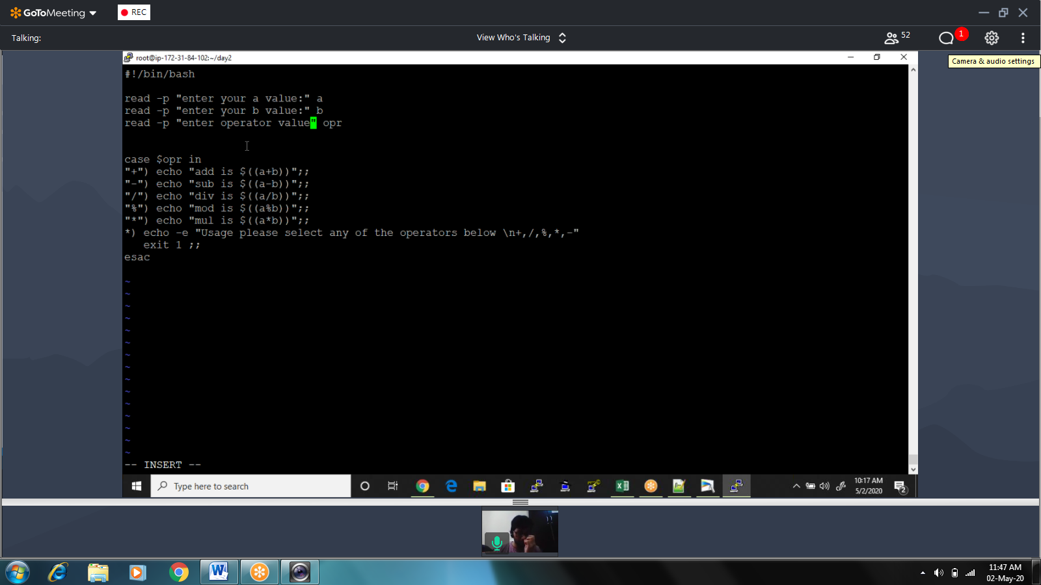

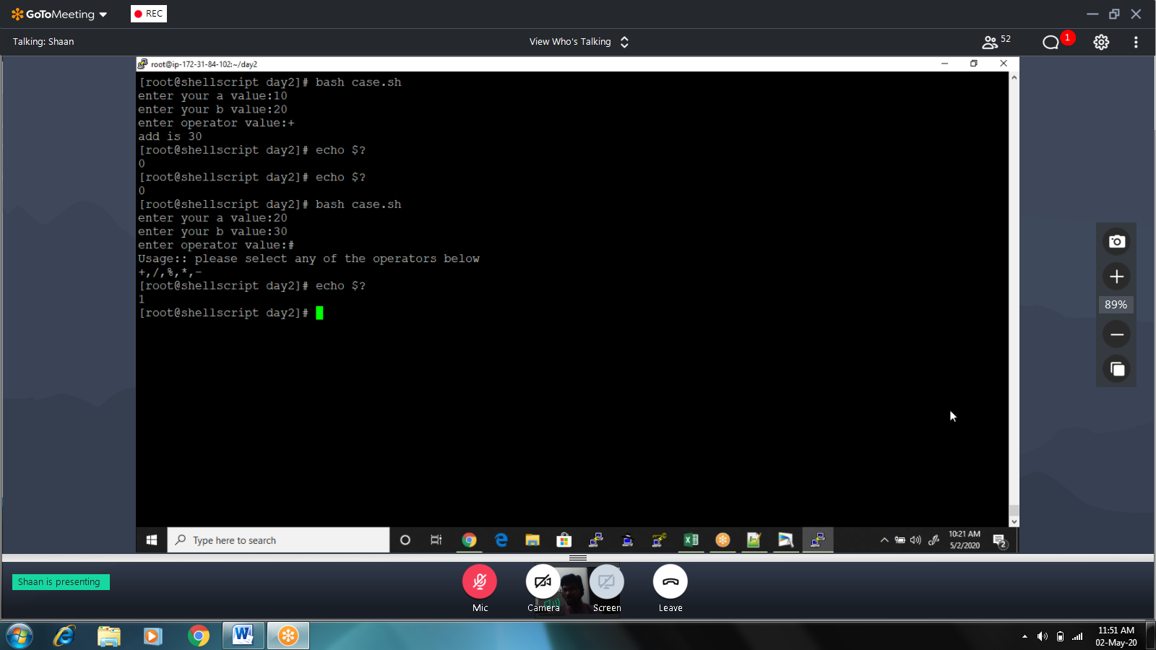

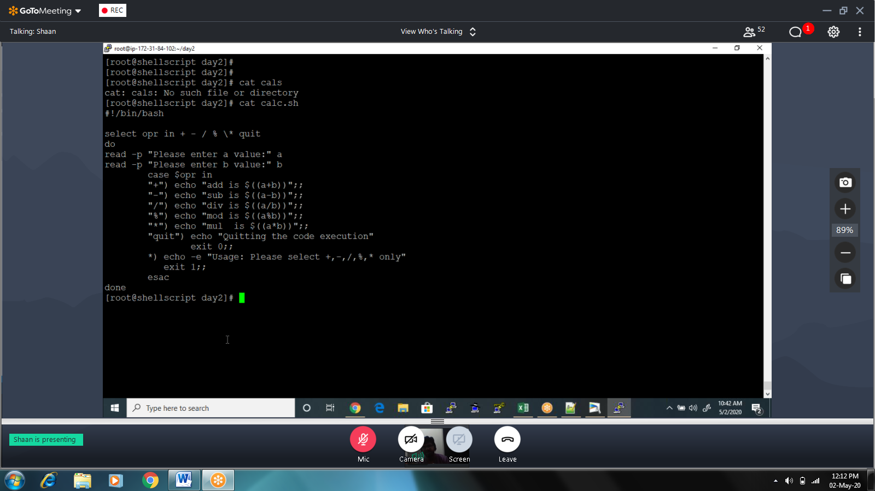

04/20

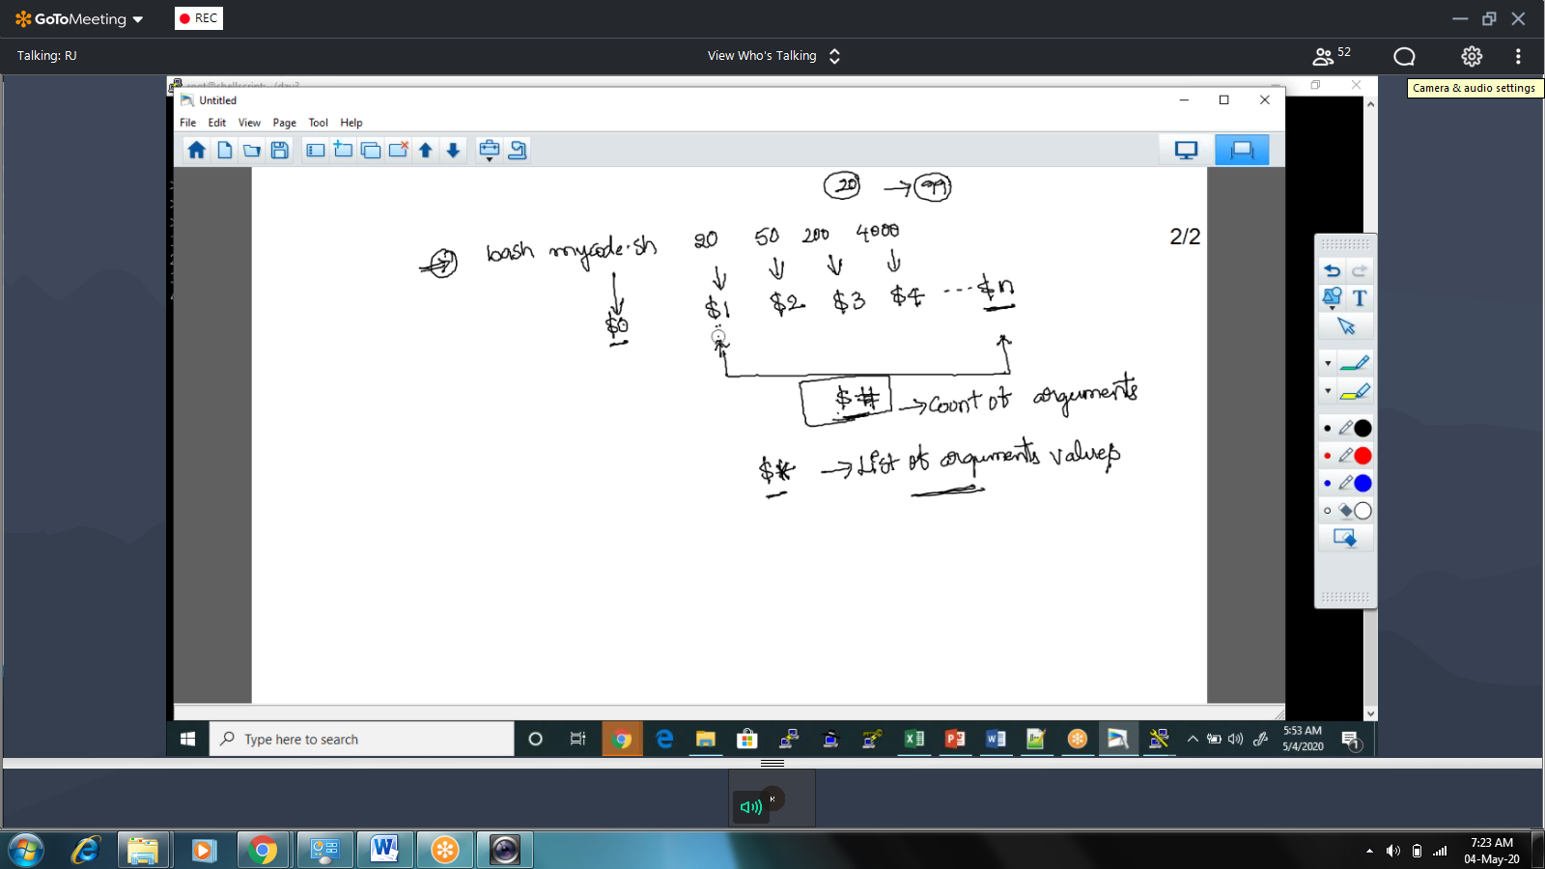

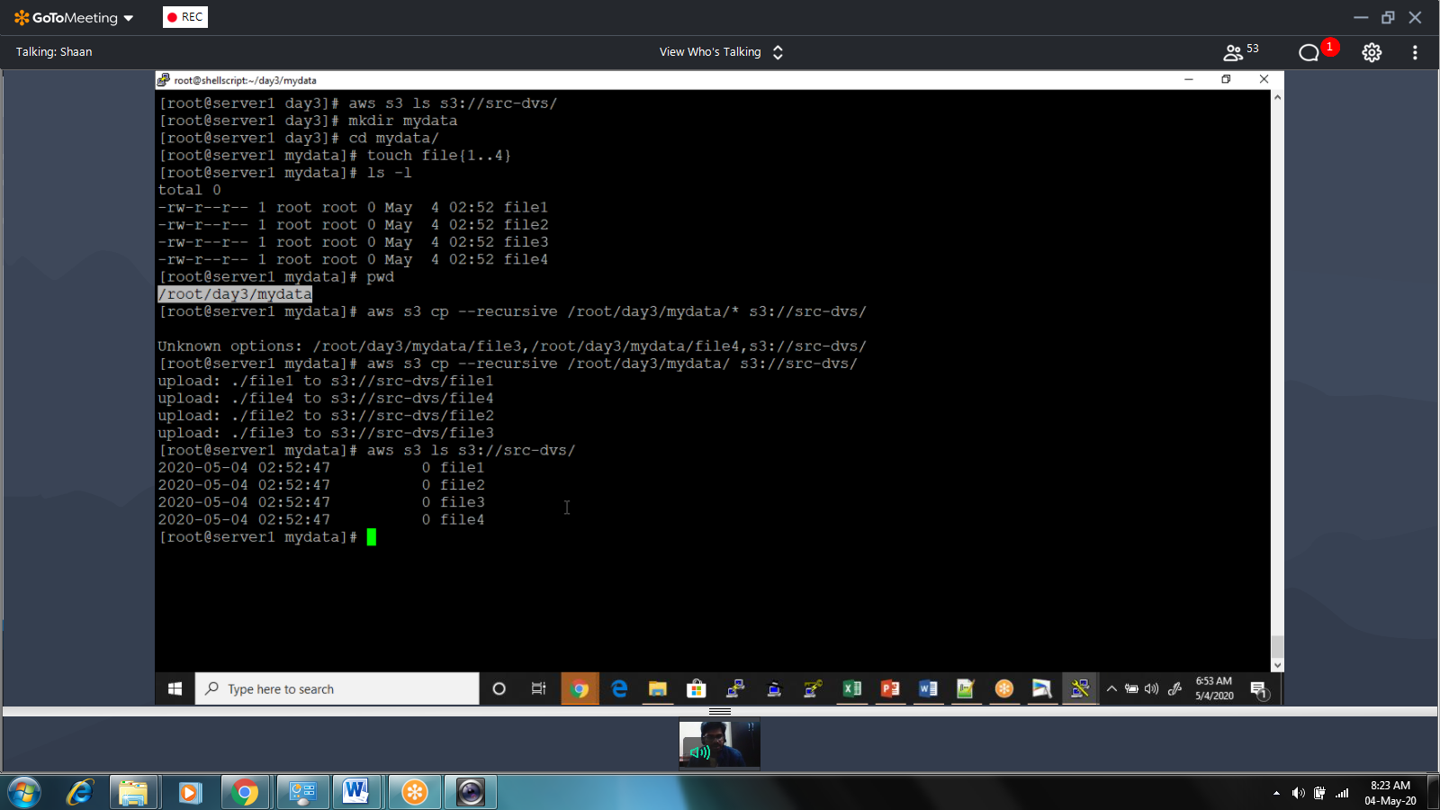

3. Write the code which accepts only two arguments source & target buckets it should copy data from source to target bucket.  
  
4. Collect the server data as per the question 2 & send one email to your manager (shahan.aix@gmail.com)  
  
aws --region us-east-1 sns publish --topic-arn "arn:aws:sns:us-east-1:353664852275:Billing" --message "serverinformation"  
aws sns publish --topic-arn "arn:aws:sns:us-west-2:0123456789012:my-topic" --message file://message.txt  
  
5. Automate the process of uploading server logs to s3 bucket by 4AM everyday  
  
ex path:  
/var/logs/

